*IT Initial Curriculum Assessment Task*

Complete the tasks below and hand in to your tutor via the electronic hand-in system (Turn-It-In) before the end of your first week. **27/09/2019**

**Task 1**

Purpose: *“To understand the key components of a computer and know where to buy them.”*

**Task:** Using a suitable website, produce a list of components that you would need to build a budget pc, you have a limit of £350. Make sure you include every component required, with cost. List the components (hardware only) in descending order of price, you could use Excel to sort the data.

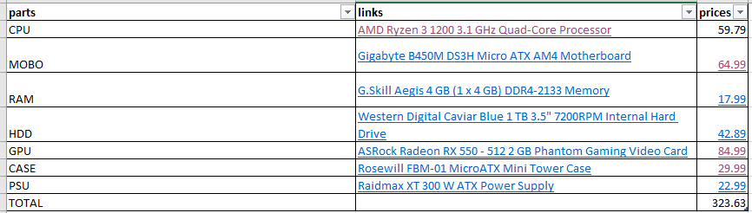

**5 marks**

**Task 2**

Purpose*: “To understand that computing devices are diverse and can be found in many different contexts.”*

**Task:** Write up a summary of **3** recent technological developments suitable for the consumer market (i.e. likely to be found in the home) for example wearable technology. Explain each of the developments, their functions, benefits etc., and include an example, with approximate price.

Amazon echo (alexa) - £140 – smart speaker and AI to tell you your arrangements in your phones( connected device by bluetooth) calendar or play music.

Smartwatch - £75 – links to phone and can be useful by monitoring your pulse and heartrate when you exercise, give you easier access to calls and texts.

3d printing - £400 to £4000 - users to print an object as 3-Dimensional CAD (Computer Aided Design) images. Also called as additive manufacturing, 3D printing is an innovative technology that helps businesses cut costs and develop new methods of production.

**8 marks**

**Task 3**

Purpose*: “To understand that high grades require higher level skills – reading, reflecting, evaluating.”*

“The continuing controversies concerning ‘fake news’ have shown us that it is impossible to know the truth about anything’. How much do you agree or disagree with this statement? Use some specific examples in your response.

I disagree to an extent as there will always be misleading information on the news and pretty much anywhere, but there is also truth hidden there sometimes. And most of this so called ”fake news” is just spiced up real news with misleading clickbait titles to gain more views and catch peoples attention like for example a robbing could be labelled as a hate crime but it isn’t true.

I also agree with this statement to an extent as there is a mix of truth and lies in the news and you can never be 100% sure if there is any reliable sources out there. Companies such as facebook have been involved in numerous scandals such as the Cambridge analytica data collections.

**6 marks**